[Clistivan art text](http://www.clistivan.com/)

For administration purposes:

 Deposit received

 Balance received / Due……………..

 Confirmation sent

 Travel directions

### Booking Form

|  |  |  |  |
| --- | --- | --- | --- |
| **Prices 2017** | Mid | High | Peak |
| **Per week in Euros** | **390 €** | **490 €** | **625 €** |

|  |  |  |  |  |  |  |  |
| --- | --- | --- | --- | --- | --- | --- | --- |
| FULL NAME: |  | | | | | | |
| ADDRESS: |  | | | | | | |
|  | | | POSTCODE: | |  | | |
| TELEPHONE: |  | | E-MAIL: | |  | | |
| COTTAGE: Please tick cottage required | | Chêne | |  | Hêtre | |  |
| BOOKING PERIOD: Number of week(s) | | |  | | Nights: | (low season only) |  |
| FROM: |  | | TO: | |  | | |
| NUMBER IN YOUR PARTY: | | ADULTS: | |  | CHILDREN: | |  |
| I saw you advertisement in: | |  | | | | | |

|  |  |  |  |  |  |  |
| --- | --- | --- | --- | --- | --- | --- |
| Please tick if you require: | Cot |  | Highchair |  | 5th Bed |  |

|  |  |  |
| --- | --- | --- |
| TOTAL RENTAL: |  | Euros |
| Complete **either** **A** or **B**: |  |  |
| **A** I am sending 25% deposit to confirm my booking |  | Euros |
| OR |  |  |
| **B** I am sending full payment |  | Euros |

N.B. The 25% deposit is required before a booking is confirmed, and is non-refundable. All bookings made within 6 weeks of the start date must be PAID IN FULL. You are advised to take out travel insurance which includes cover for cancellation costs.

I HAVE READ THE TERMS AND CONDITIONS OVERLEAF AND ACCEPT THEM ON BEHALF OF ALL OF MY PARTY RESIDING IN THE PROPERTY, ON WHOSE BEHALF I AM DULY AUTHORISED TO MAKE THIS AGREEMENT. I AM OVER 18 YEARS OF AGE.

|  |  |  |  |
| --- | --- | --- | --- |
| SIGNED: |  | DATE: |  |

Please pay by Internet/Bank Transfer (bank details attached)

# Return to:- Mr & Mrs Richardson-Smith or e-mail: [contact@clistivan.com](mailto:contact@clistivan.com)

# Clistivan

56500 La Chapelle Neuve

France

[Clistivan art text](http://www.clistivan.com/)

### Booking Conditions

1. CLISTIVAN (“the property”) is offered for holiday rental to the TENANT NAMED OVERLEAF (“the client”) subject to conditions set down by LYNDSEY RICHARDSON AND ANDREW SMITH (“the owners”).
2. To reserve the property the client should complete and sign the booking form and return it via mail or email. The non-refundable deposit (25% of the rent due) must be paid by bank transfer in Euros. Following the receipt of the booking form and deposit, the owner will send a receipt and booking confirmation. This is formal acceptance of the booking.
3. The balance of the rent is payable NOT LESS THAN 6 WEEKS before the start of the rental period. If payment is not received by the due date the owner reserves the right to give notice in writing that the reservation is cancelled. Reservations made within 6 weeks of the start of the rental period require payment in full at the time of booking.
4. Any chargeable expenses arising during the rental period (e.g. babysitting) must be settled locally prior to departure.
5. A damages deposit of 150 € (or £130) is required in case of damage to the property or its contents. However the sum reserved by this clause shall not limit the client’s responsibility to the owner. The damages deposit must be paid in cash on arrival. 40€ (or £30) of the deposit represents the optional cleaning charge. The owner reserves the right to deduct this if the cottage is not left in a clean condition. The owner will account to the client for the damages deposit, and refund the balance at the end of the rental period.
6. Subject to clauses 2 and 3 above, in the event of non-insurable cancellation, refunds will be made if the owner is able to re-let the property, less an administration fee of 30€. The client is strongly recommended to arrange a comprehensive travel insurance policy, as personal belongings are not covered under the owners insurance.
7. The rental period commences at 4pm on the first day and finishes at 10 am on the last day. The owner shall not be obliged to offer accommodation before the time stated, and the client shall not be entitled to remain in occupation after the time stated.
8. The maximum number of people to reside in the property must not exceed 5, unless the owner has given written permission.
9. The client agrees to be a considerate tenant, and to take good care of the property, and to leave it in a clean and tidy condition at the end of the rental period. The owner reserves the right to make a retention from the damages deposit to cover additional cleaning costs if the property is left in an unacceptable condition.
10. The client agrees not to smoke inside the property and not to bring any pets without written permission. The client agrees not to act in any way that would disturb neighbouring properties.
11. [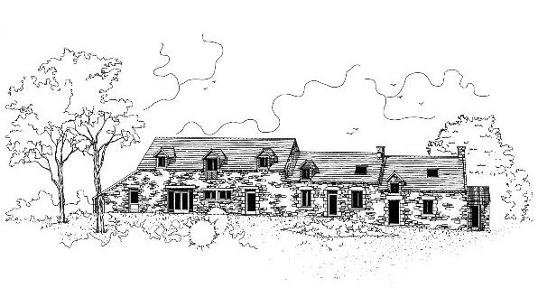](http://www.clistivan.com/)The client shall report to the owner, as soon as possible, any defects in the property or breakdown of equipment or appliances, and the owner will make arrangements for repair and/or replacement as soon as possible.
12. The owner shall not be liable to the client;

* for any temporary defect or stoppage of public services to the property
* for any loss, damage, injury which is the result of riot, war, strikes, adverse weather conditions, or other matters beyond the control of the owners.
* for any loss, damage or inconvenience suffered by the client if the property becomes uninhabitable before the start of the rental period, and in such event the owner shall notify the client and refund all monies paid in respect of the rental period, within seven days.

1. Under no circumstances shall the owner’s liability to the client exceed the amount paid to the owner for the rental period.